**Mobile Vehicle Activated Signs (MVAS)**

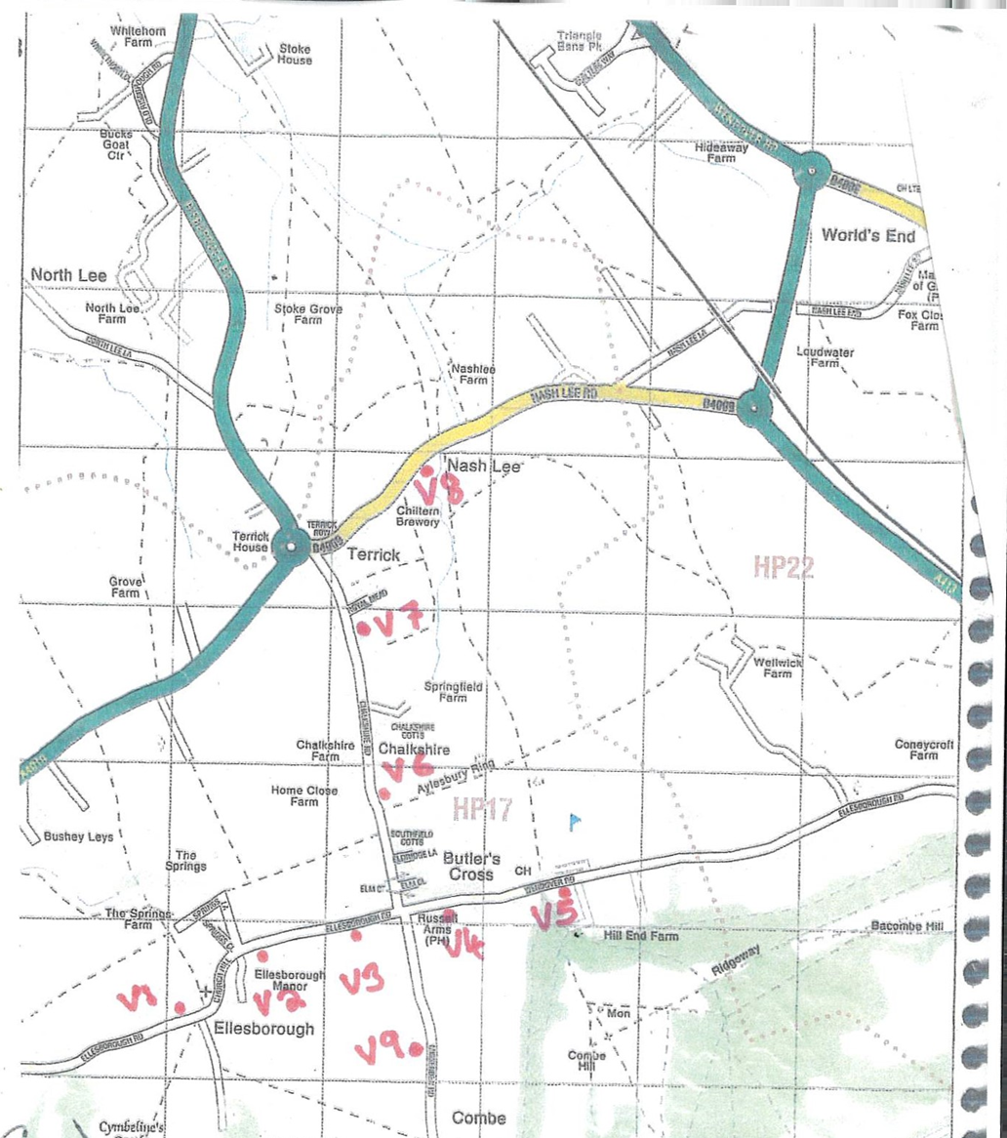Traffic and speeding through the parish has been a concern for many years. Ellesborough Parish Council have allocated funds to upgrade the MVAS, and wish to seek the views of parishioners who will have these located near their homes. The background is that EPC purchased 3 devices over 10 years ago and 9 sites in the parish were approved. These can be seen on this map and are:

2 sites in Chalkshire Rd, 3 sites on Ellesborough Rd, 2 sites on Wendover Rd, 1 site on Missenden Rd, 1 site on Nash Lee Rd

EPC intend to purchase 2 new devices that will be solar powered, and via Bluetooth connection will record volume of traffic in both directions, as well as the speeds. The signs will flash the speed but can be set so it doesn’t encourage reckless drivers to try and go faster than previous recorded speeds. We will then be able to have 3 sites in operation with MVAS as the two new devices, and 1 of the older devices. These can then be set up and moved around the 9 different sites at regular intervals.

While these devices will be a visual reminder to all drivers of their speed through the parish, the information we will collect can be used to provide a 24/7 picture of the volume of traffic and the speeds through the parish, and so support campaigns to address the issues that concern us all.

We would like to hear your views on having these sited near your homes and invite you to write or email to the Parish Clerk on : -

[clerk@ellesborough-pc.gov.uk](mailto:clerk@ellesborough-pc.gov.uk) Please comment by 29th Feb 2024.